Eventi
Use Case Specification

Submitted to:

Asst. Prof. Ma. Rowena C. Solamo
Faculty Member
Department of Computer Science
College of Engineering
University of the Philippines, Diliman

Submitted by:
Dimaano, Aaron Diego I.
Lopez, Matthew S.
Torres, Jacob Angelo V.

In partial fulfillment of academic requirements
for the course
CS 191 Software Engineering I
of the
1st Semester, AY 2015-2016
Unique Reference:
The documents are stored in https://github.com/Tom-2013-06417/CS191-192_Event_Sharing/tree/master/02-Requirements%20Engineering.
Link to this document: https://github.com/Tom-2013-06417/CS191-192_Event_Sharing/blob/master/02-Requirements%20Engineering/4.0%20-%20Manage%20home%20page.pdf.

Document Purpose:
The purpose of this document is to exhaust the step-by-step process of the Use Cases in every scenario possible.

Target Audience:
To our project client and adviser, our fellow 191 classmates, and our future selves when they need to refer back to this document.

Revision Control:

Revision Date | Person Responsible | Version  Number | Modification
09/18/15 | Dimaano, Diego  Lopez, Matthew  Torres, Jacob | 1.0 | Initial Document

Use-Case Name: Manage home page

Description: This is a feature concerning the Registered User. This allows for customization of what events are to be displayed to their home page based on their subscriptions. Additional customizations include display by relevance or popularity.

Preconditions: The Registered User has logged-in into the account and has a list of subscribed organizations showing their event highlights.

Flow of Events:

Scenario Name | Description
Scenario 1 (Basic Flow)  Registered User assertively unfollows a subscription | - Registered User proceeds to the board management page  - Registered User selects the Organizations they would like to unfollow  - System verifies the Registered User 's decision  - Registered User is sure about the decision and proceeds with unfollowing the Organization
Scenario 2  Registered User is skeptical in unfollowing a subscription | - Registered User proceeds to the board management page  - Registered User selects the Organizations they would like to unfollow  - System verifies the Registered User 's decision  - Registered User decides not to proceed with unfollowing the Organizations  - System prompts Registered User if they would like to be redirected to the home page or the board management page

Activity Diagram of the Flow of Events:

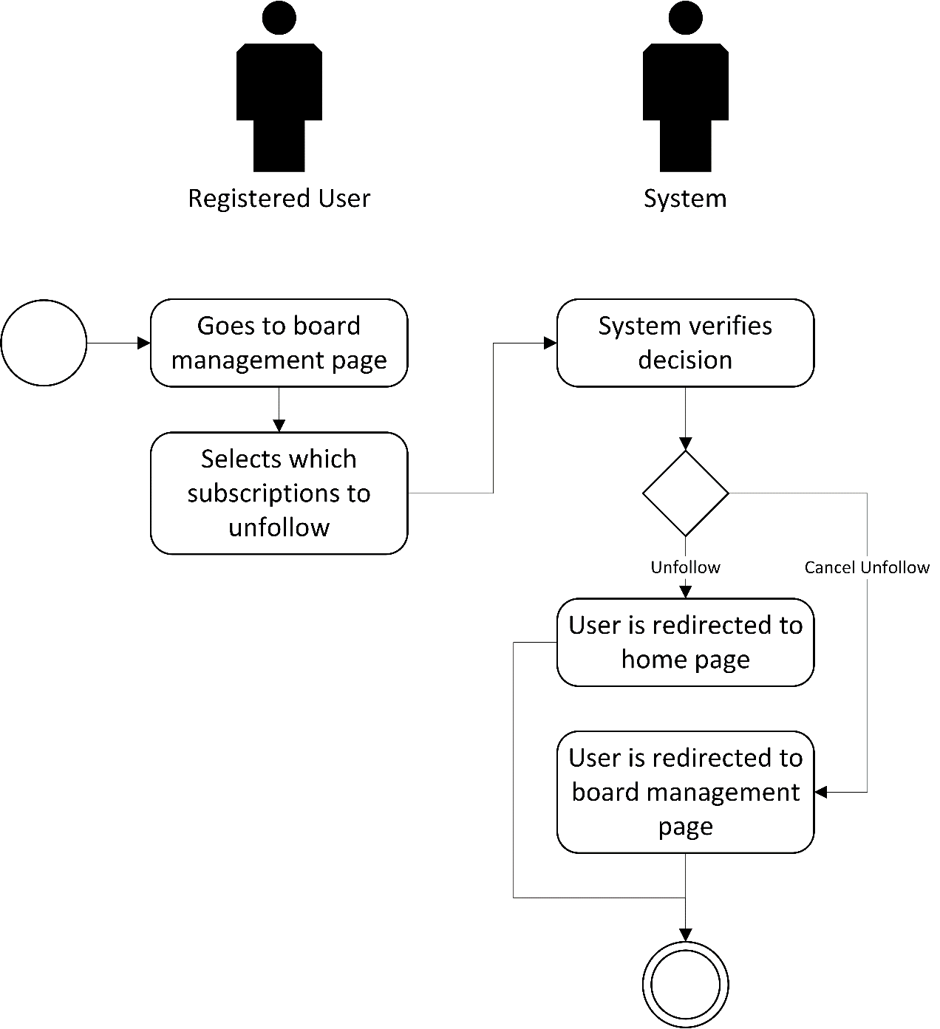

Post-conditions: Successful: The Registered User’s homepage successfully customized home page.
Failed: The Registered User’s customizations did not push through.

Special Requirements: NONE

